FATE OF BJP GOVERNMENT IN 2019 ELECTIONS



SUBMITTED BY:
NAME ROLL NO.
PARITOSH SHARMA 101803497
PRIYANSH BANSAL 101803511
JATIN AGGARWAL 101815123
SHREY PANDEY 101853009

Semester-II (January-May 2019)

INDEX
Content Page No.

Certificate 3

Preface 4

Acknowledgement 5

Abstract 6

Introduction 7

Literature review 8

Data analysis and interpretation 11

Research methodology 21

Conclusion 23

Limitations of study 24

References 25

CERTIFICATE

This is to certify that the report titled –“FATE OF BJP GOVERNMENT IN 2019 ELECTIONS” embodies the original work done by the undermentioned students of Group N-3 under my supervision.

NAMES ROLL NO.
PARITOSH SHARMA 101803497
PRIYANSH BANSAL 101803511
JATIN AGGARWAL 101815123
SHREY PANDEY 101853009

DR. RAKESH SHARMA

(SIGNATURE)

Thapar Institute of Engineering & Technology,
Patiala, Punjab.
147004

ACKNOWLEDGEMENT

While compiling this report we took the help and guidance of several respected personnel who deserve our greatest gratitude. The completion of this report gives us great pleasure. We, the students of group N-3 would specially like to thank our teacher Dr. Rakesh Sharma for his constant support and guidance throughout the entire course of this project. We would also like to expand our deepest gratitude to all those who have in any way either directly or indirectly helped us in writing this report. We would also like to acknowledge the contribution of our friends in this report.

PARITOSH SHARMA
PRIYANSH BANSAL
JATIN AGGARWAL
SHREY PANDEY

PREFACE

This project report has been prepared in partial fulfilment of the requirement for the subject: PROFESSIONAL COMMUNICATION of the program B.E. (Semester-2) in the academic year 2018-2019.

For preparing the project report, we have conducted a poll during the suggested time interval to avail the necessary information. The blend of learning and knowledge acquired during our practical studies is presented in this project report.

This report presents that what the public opinion is like in the build up to the General Elections of 2019. The biggest festival of democracy is around the corner and the country is well and truly getting ready to celebrate it.

The report mainly persuades people to give a feedback of how they feel of the work done since the last elections and what is the possible outcome of the elections in their vision.

ABSTRACT

The report concerns the result one could expect out of the general elections to be held in summers 2019. Elections are simply the biggest celebration of democracy which arrives every 5 years. This is a small attempt to get a probable idea of what to expect.
The preparation of this report has been based around a mini survey that was conducted by our group. The survey included questions which covered various aspects over which a govt.’s performance is ought to be judged. The responses have been received from people of various age groups and walks of life.
We have received responses from 133 people. The opinions differ from one aspect to other. The present government has got a thumbs up for its progressive decision making but the economic repercussions seem to concern the public in general. Some specific sectors like foreign relations and defence sector seem to impress the people.
The study of the responses gives an impression that the public seems to be divided on who they want to see as the ones at helm of the powers of this nation. The public opinion is giving different sentiment regarding different sectors.
The absolute conclusion of the report gives an impression that currently we are facing a democracy with lack of options as the opposition doesn’t look convincing either in its arguments or in its leadership.

INTRODUCTION

India is a democracy and for its good health, elections are the periodic necessary vaccine. In India, elections are held after every five years for the Lok Sabha i.e. the lower house of the parliament. For a democracy to keep up its sanity it is necessary to allow the power shift from one hand to other and let the citizens decide upon it. Thus the elections give this opportunity to the citizens.

Elections is a process which makes the people’s representatives answerable and responsible to work for the welfare of the citizens. This is because elections give the citizens the power to change their representative if not satisfied with his/her work. Thus, the elected one’s have to be on their toes to win back the trust of the people in order to remain in power.

As we all know the general elections of 2019 are around the corner hence this report is a sincere effort towards knowing the general sentiment as the political scenario of the country heats up. Here we have conducted a poll which general concerns the performance of the present government.
The questionnaire which was prepared persuaded the responders to give their general impression of the performance of various sectors and the way society has shaped up since the last elections.
Our report had majorly reached out to the first time voters, so the outcomes of the poll reveal some fascinating details of what the current youth thinks of the existing political scenario of the country.

The 2014 general elections were a mile stone in the history of independent India. 4 decades after the win of Indira Gandhi in 1960’s it was the first time a party had gained absolute majority to reach the helm of powers at the centre. The dominance of UPA alliance had found a strong opposing force which was destined to dominate the political scenario in the coming future.
The NDA alliance stormed through the elections by showing how the previous governments had failed and projected the vision of a new look India. They promised of the much anticipated “Ache Din” and used the credentials of Narendra Modi as a working and performing leaders through his works in the much improved state of Gujarat.
But that was then and now, 4 years later, the NDA government is in the spot as they have got all the 5 years they wanted and now it’s their turn to show how they have done good or better than the earlier ones.
And this is what the report seeks for, that how this government has affected the people in its full term.

REVIEW OF LITERATURE

A study of the past literature would help the researchers to understand the various dimensions of the present research problem clearly and would act as a guideline for carrying out the present study. Therefore, in this chapter an attempt has been made to review the literatures relating to voting behaviour.
Mukhi H.R. in his book states that voting behaviour is influenced by caste, religion, region and several other factors. Yogendra Kumar Sharma in his book opines that absence of education is a big handicap in creating a truly democratic state because during elections the ignorant people are persuated to vote the wrong person. J.L. Kachroo and Vijay Kachroo in their work opine that voting like party system is the means to select the legislators who perform the decision making function in a democracy. Voting has a pattern of its own. Generally educated and urban electorate feels more involved. The illiterate and lower classes are sometimes apathetic to it. Some people traditionally vote the same party. The Election Commission of India in its Report has pointed out that majority of the Indian population consists of illiterates and the illiterates may not be able to exercise their votes intelligently and freely. Manoj Sarma in his book views that caste, religion, regionalism, ideology and community are the important factors that influence the behaviour of voters. According to him seat to a candidate contesting to the Parliament and State Legislatures is decided on the basis of the caste dominance. He opines that particular percentage of people is swayed by religious slogans created by the communal parties for their selfish ends. The communalist voters have voted for particular communal parties in India and influenced by religious considerations. Regionalism means love of a particular region in preference to the country. According to him voting behaviour in India is also very much influenced by regionalism. Certain persons may be committed to ideology but he votes for a candidate who is related to him irrespective of ideology he follows.
C. Agarwal’s book consists of four parts. The first part deals with nature, scope and methods of political science, behavioural revolution in political science, post-behaviouralism relation political science to other social sciences state, state, nation and nationality, the nature of the state. nation and nationality, the nature of state, idealistic or metaphysical theory, theories regarding the origin of the state, sovereignty and pluralism, concepts of welfare and secular, state, relation between the individual and state, liberty and equality, state, law and punishment, international law (relations between states and theories of coexistence, panch sheel internationalism and united nations, forms of government, theory of separation of powers, political parties and local self government public opinion. The second part deals with political system, political, political culture, political socialization, power influence, authority and legitimacy political elites, modernization and political development and nationalism and imperialism. The third part deals with individualism, utilitarianis socialism, communism and collectivism, anarchism syndicalism guild socialism, fascism and Nazis Gandhism and Sarvodaya. The fourth part deals with Marxist theory about the origin the state Marxist, theory about the origin the state, Marxist, theory of rights Marxist, concepts of liberty, equality property, justice pressure group and miscellaneous topics. According to him people caste their vote for the party whose programmes and policies impress them. Thus policies and programmes of the political parties are the important factors responsible for voting behavior
Sr sharma in his book has talked about the things related to elections in India, in special context of the 1999 elections. In this book he has pointed out that most people vote either because they are strongly against some candidate or party or because they feel themselves under a personal obligation to someone to vote.
The book edited by B.B. Goswami and Jayanta Sarkar comprises of articles titled Ethnicity, Politics and Political System in Sikkim by S.Ghosal, Ethnic Politics in a Matrilineal Situation by S.K.Mukherjee, Some Aspects of Tribal Ethnicity in Western Orissa by N.K. Das, Ethnic Elements in an Assembly Election in Bihar by R.K. Sinha, Power, Politics and the Tribals : Study of the Process Through Vidhan Sabha Election in a Reserve Constituency for Scheduled Tribe in Bastar by R.K. Saha, Ninth Vidhan Sabha Election in a Multi- Ethnic Situation of Rajasthan by Lok Nath Soni, Election, Power and Politics in a Multi-Ethnic Situation of Gujarat by Jyotirmoy Chakraborty. After independence of India the democratic political system has been extended from the Parliament to village panchayat. The system provides scope to the eligible citizen of India to elect representatives of one's own choice in order to annex political power. The nature and extent of association of ethnic sentiment in acquiring political power and usefulness in understanding the political behaviour of the tribes have been discussed threadbare in the seven essays; based on the anthropological studies conducted in the predominantly tribal areas stretching from the northeast to the western parts of India. The sense of insecurity in respect of their cultural identity is still being maneuvered in the north-east India that generates a strong sense of ethno-centricism. The tribal people in this region classify the electorate and aspiring candidates into two categories; the 'insider' and the 'outsider'; a mechanism which, however, gradually becomes weaker and does not operate so effectively in the central and western parts of India. In this book the authors have pointed out that election manifesto and money are used by the political parties for buying votes from the people and for motivating electors the political parties express the plans and programmes which they want to fulfill if they come to power. M.Roy in his book has pointed out that Indian Democracy, a vibrant one, has withstood many a challenge. It has witnessed twelve Lok Sabha Elections. The author has developed an expertise in election studies. This book is the fourth in the series of election studies. The book incorporates valuable data which helps in the understanding of the electoral politics and general elections in a most comprehensive way. It also gives in a compact form about the election results in the states too. For some time India has come to settle with the coalition politics. Many a time elections have been forced upon the country without the Government at the centre completing its full term. Elections had been forced upon the country by the Congress when it withdrew support from the Central Government. Due to coalition of many parties, more so by the regional parties, the Governments at the centre have fallen by the way side.
Evaluation

Under the heading voting behaviour a number of works relating to voting behavior such as Political Science, Bhartiya Rajnitik Vicharak, Rural Sociology, Introduction to Political Sociology, General Sociology, A Dictionary of Sociology, Economic Growth, Governance and Voting Behaviour: An Application to Indian Election, Political Parties, The City Voter in India, Voting and Election, Elections and Political Development: The South Asian Experience, Report on First General Election in India, Indian Government and Politics, Theory and Government and Politics, Political Science Indian Government and Politics, Paper I (Section B), Public Administration: Concepts and Theories, Elections and Political Development: The South Asian Experience, Electoral Politics In India: Election Process And Outcomes, Voting Behaviour And Current Trends, Parliamentary Democracy: The Indian Experience, Modern Politics and Government, Indian Politics, Contemporary Issues and Concerns, Political Theory,
Comparative Politics, Political Behaviour, Indian Polity: Structure and Process, Political Marketing in India, Political Behaviour, Spatial Fragmentation of Political Behaviour in India, Major Issues in Indian Elections 1999, Electoral Politics in Federal India, Comparative Politics, Ethnicity, Politics and Political Systems in Tribal India, India’s 1999 Elections and 20th Century Politics, State and Politics in India: Themes in Politics (OIP), Political Development in India, Lok Sabha Elections Since 1952, Indian Polity, Constitution and Parliament, Electoral Politics in India: Election Process and Outcomes, Voting Behaviour and Current Trends, Populism, Tamil Style: Is it Really a Success?, We Get What We Vote For-Or Do We?: The Impact of Elections on Governing, The Measurement of Voting Power: Theory and Practice, Problems and Paradoxes, Social Cleavages and Political Change: Voter Alignments and U.S. Party Coalitions, The Demobilization of American Voters: A Comprehensive Theory of Voter Turnout and Economic Voting have been reviewed. The above literatures reviewed and appended in bibliography have not analyzed in detail the voting behaviour in Tamil Nadu with reference to Tirunelveli Parliamentary Constituency. The researcher thought that a detailed study on the voting behaviour with reference to Tirunelveli Constituency would bring to light the reasons for political apathy and the factors that influenced the voting behaviour and responsible for political involvement of the people. Therefore, the researcher thought it appropriate to take up this research study for detailed analysis.

DATA ANALYSIS AND INTERPRETATION

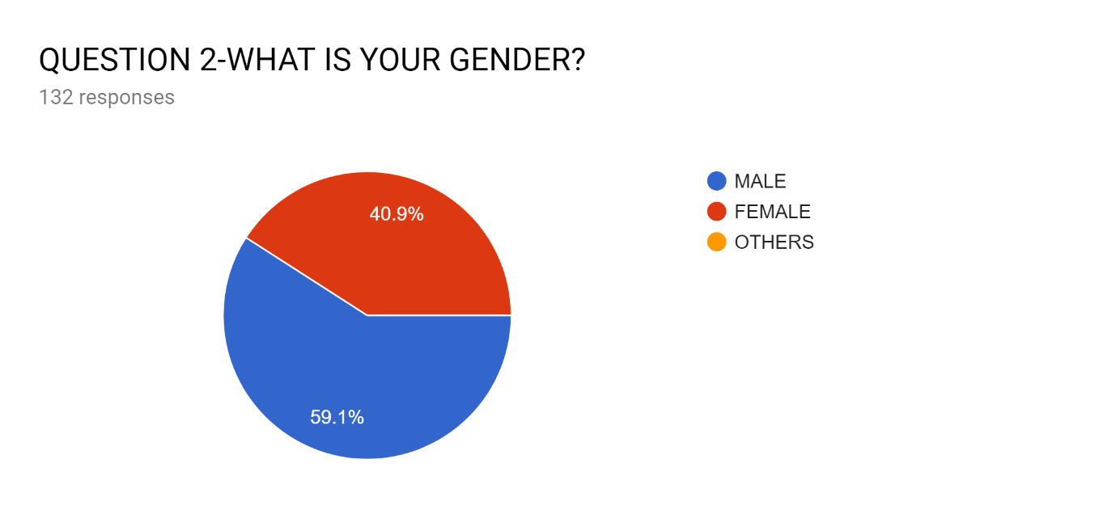
The sex ratio of girl is to boy was 0.692 which is very closer to 1 i.e. our report was not gender biased and contained approx.. equal participation of girls and boys.

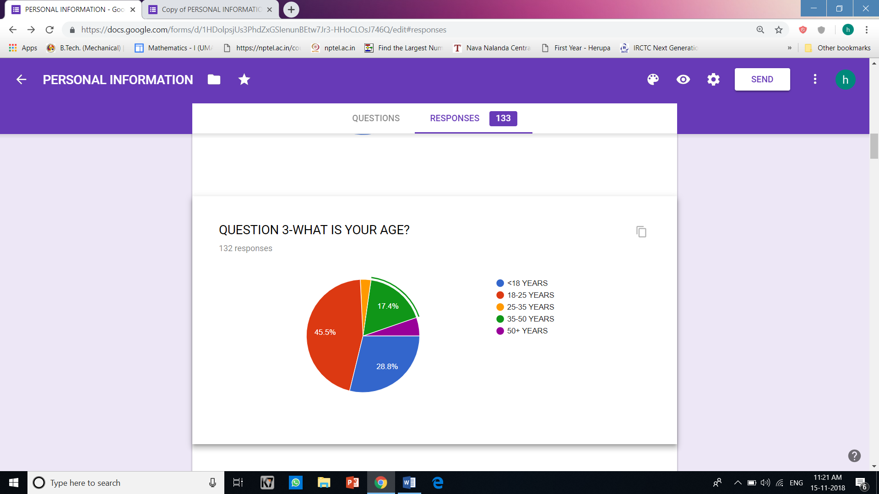
Our report almost touched every age group from <18 to 50+ age of people. Our report was dominantly filled by people belonging to age group of 18-25 years i.e.it included the youth opinion. Approximately 28.8% belonged to less than 18 years age group so our report contains the opinion of future voters. People from age group of 50 above i.e. it also covered the opinion of mature people of the society .

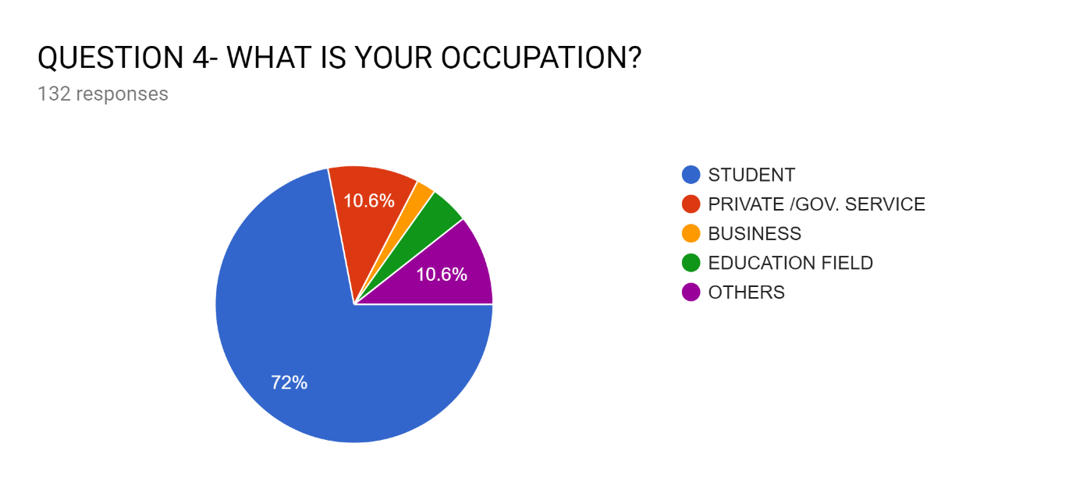Our report was more inclined towards students, approx., 72% of people who filled the responses were students. The form was also filled by people from other backgrounds like business and education. About 10.6% of people belong to govt. sector jobs. So, in our report we are able to get the opinion of the people working with the government also. 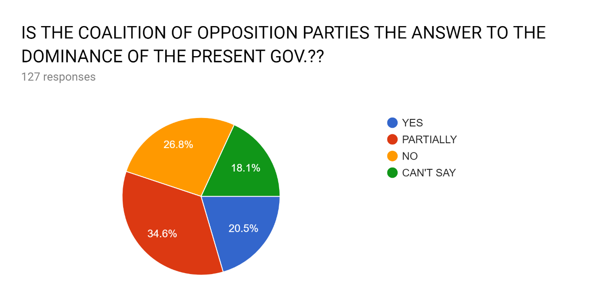Based on the received responses people seemed to be in favour of the present govt.
They have been very tactful i.e. have been able to grab the attention and respect of people with its policies focusing every sector of society and reinitiated the policies of previous govt. with a better management plan, which impressed the civilians and created a fear among the other parties that led to coalition of opposition parties against the present govt.
Examples – Assam
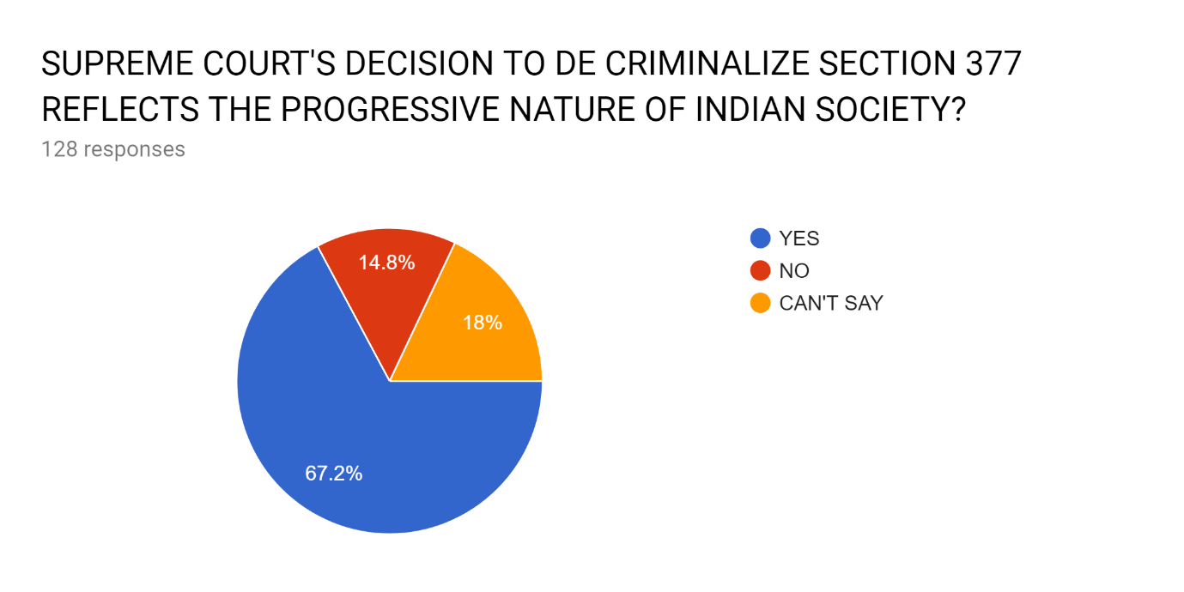
The section 377 of Indian constitution criminalises any sexual interaction between two individuals of either of the LGBT (i.e. Lesbian, Gay Bisexual, Transgender) orientation. This shows that how the society collectively has become accepting to any differences that exist in our society.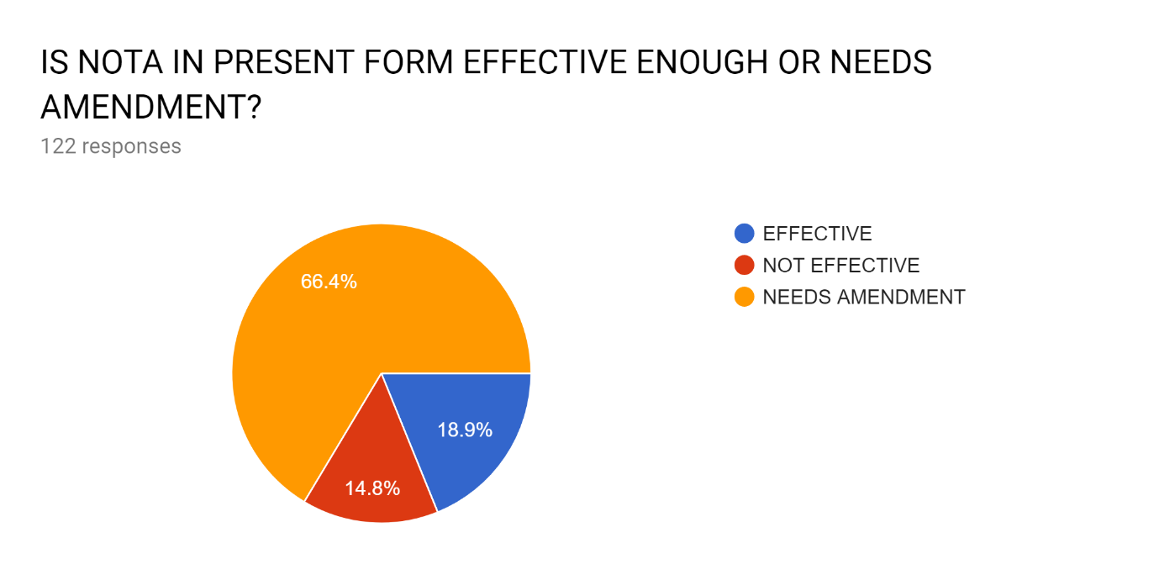

In principle, NOTA is one of the very effective electoral reforms if enacted in full power. This is what the public also thinks of the NOTA presently. If more people have voted for NOTA as compared to real candidate then that constituency undergoes by-elections but this doesn’t happen presently. Thus the public also demands for the complete right of not selecting any of the available choices if it has the right to choose their desired leader.
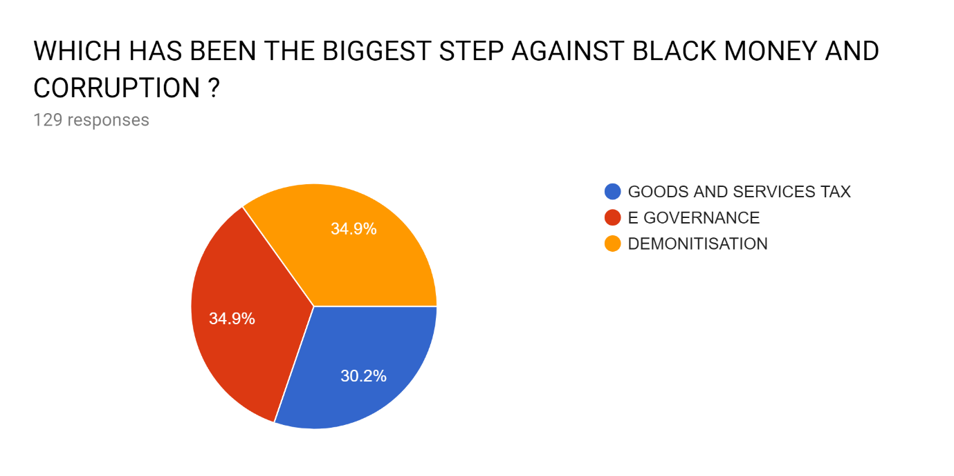
Responses to this question show that despite government’s repeated claims of having combated corruption effectively, the public isn’t finding any of the steps taken as yet absolutely effective. From the pie chart GST and demonetisation seem to have impressed the public.
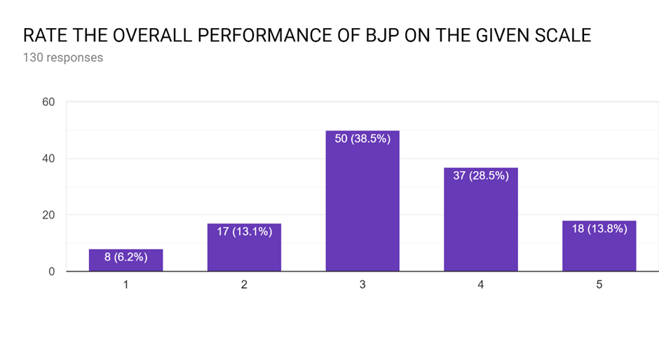
The people who participated in this poll seem to be fairly satisfied by the present government’s performance but not much. However the public response is heavier towards the higher scores. This also reflects that people are inclined towards the present government because the opposition at the moment is also not that promising.
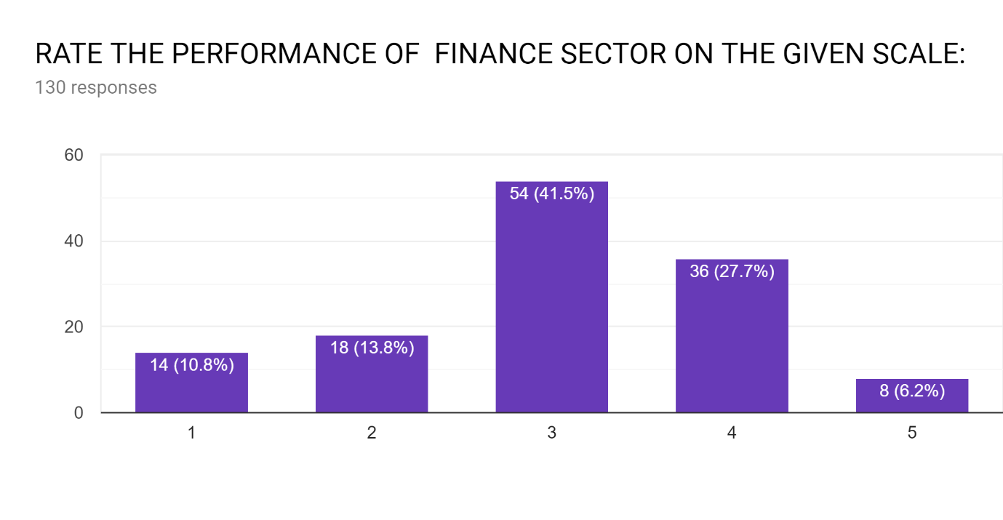
Finance sector seems to have fairly impressed the public. Some brave economic reforms like GST and demonetisation really look good in principle. These policies haven’t provided the absolutely desired results which may force the public against the government. The execution of these policies seem to be a problem for the public at present.
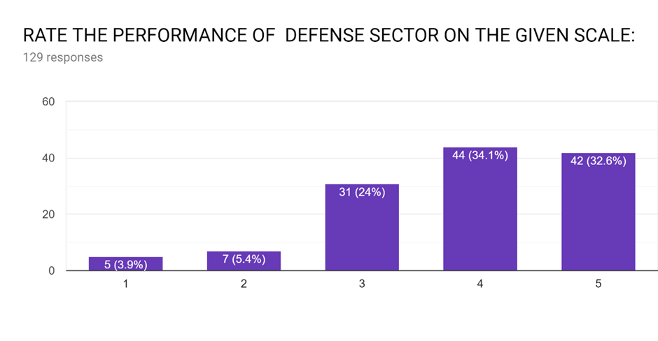
Responses to the above question give an impression that the public is quite happy with the way India has been going as far as the defence sector is concerned. The ‘Surgical Strikes’ can be touted as the major contributor to this sentiment. Other than that, India clearing the diplomatic issues surrounding the S 400 missile system that was to be bought from Russia and India’s increasing affinity towards Israel, a country with a strong defence force itself.
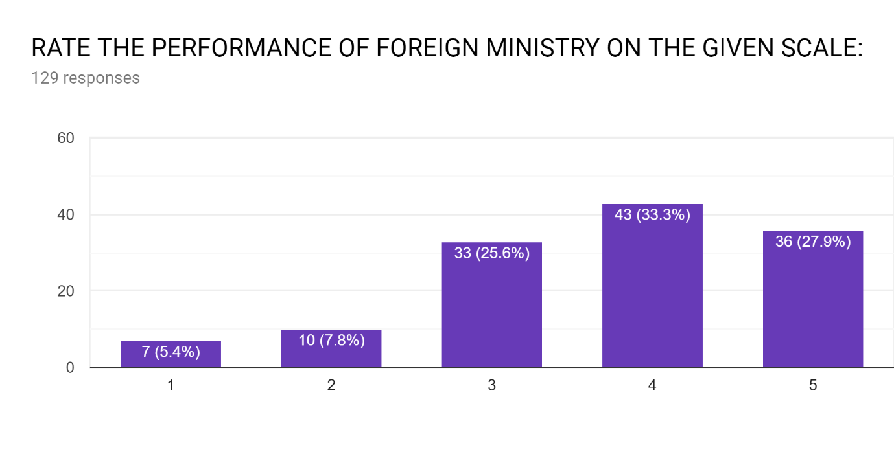
India’s foreign relations have grabbed the most headlines due to PM Modi constantly being on flight to improve India’s diplomatic ties with other countries. India having good relations with Israel, Bhutan, USA, and other important South East Asian countries seem to be the biggest gains of India in this sector.

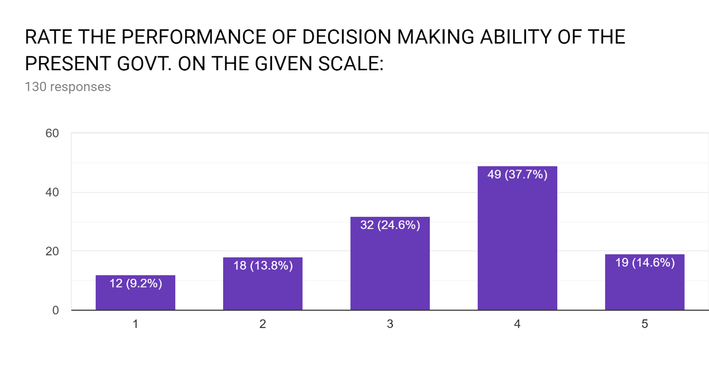
The average opinion regarding he decision making ability of the present gov reflects that the country is quite satisfied with the speed at which the big decisions have been made in the last four years. Leaving aside the credibility of the decisions various decisions like demonetisation, GST, ordinance regarding rape victims, surgical strikes etc. show that this gov. doesn’t shy away from taking steps regarding some serious reforms.

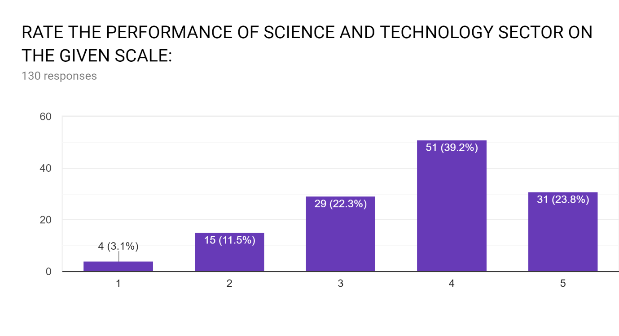
According to the above bar graph it can be seen that most of the people who filled the response are satisfied with the work of the gov.. Technology since the present gov came into power India has witnessed a great success in the field of astronomy via ISRO, the gov. started DRDO which is working in various areas of military technology which include aeronautics, armaments, combat vehicles, electronics, instrumentation engineering systems, missiles, materials, naval systems, advanced computing, simulation and life sciences. DRDO while striving to meet the Cutting edge weapons technology requirements provides ample spinoff benefits to the society at large thereby contributing to the nation building.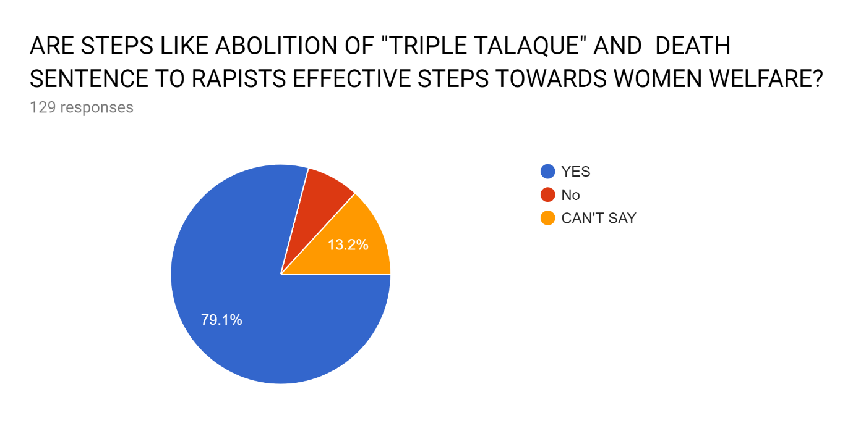
The above stated steps also reflect the impressive pace at which the present govt. has made decisions. The responses reflect the over whelming appreciation these decisions have been subjected to by the public. In an era where women empowerment is the global agenda, the present govt.’s steps are worth appreciation.
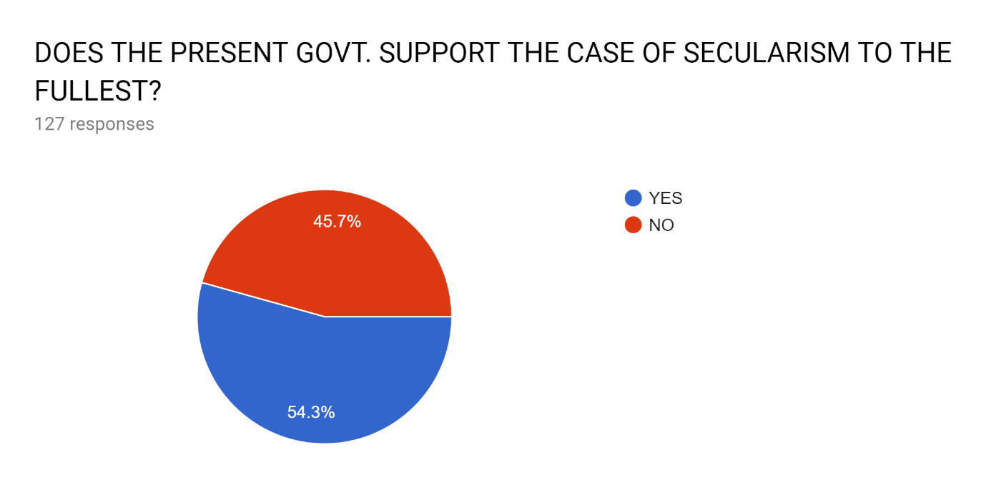
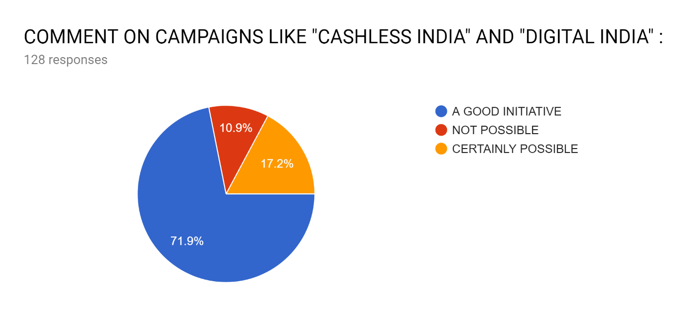
The response to this question does show that this aspect is difficult to judge. Everyday news about mob lynching reflect an argument against secularism but there is equal possibility of these news being completely true as compared what is shown.

The response to this question shows that people are satisfied with the campaigns as most of the people who filled the form belonged to youth so this question gives a good approximation of the effect of cashless India campaign on youth, as they are the one who are digitally more smarter than the old people i.e. the aged group
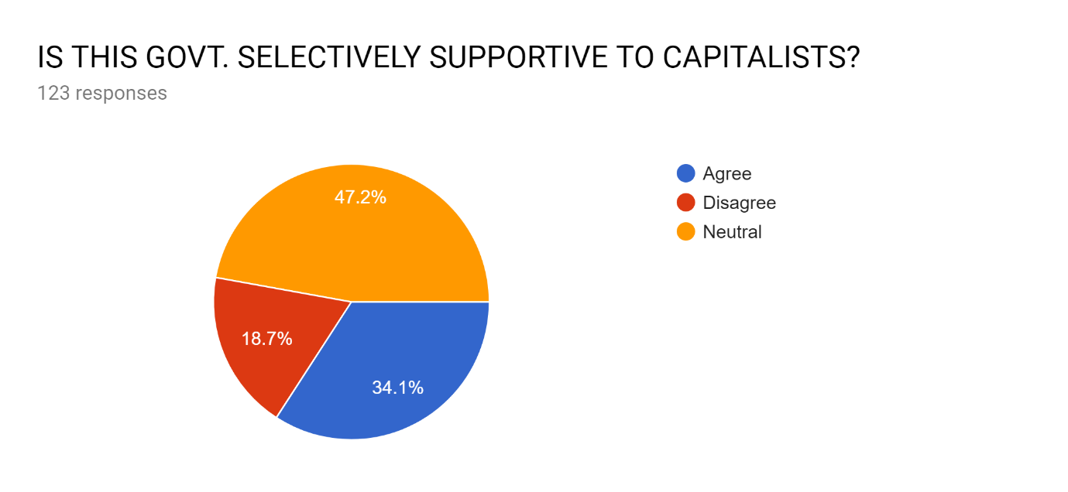
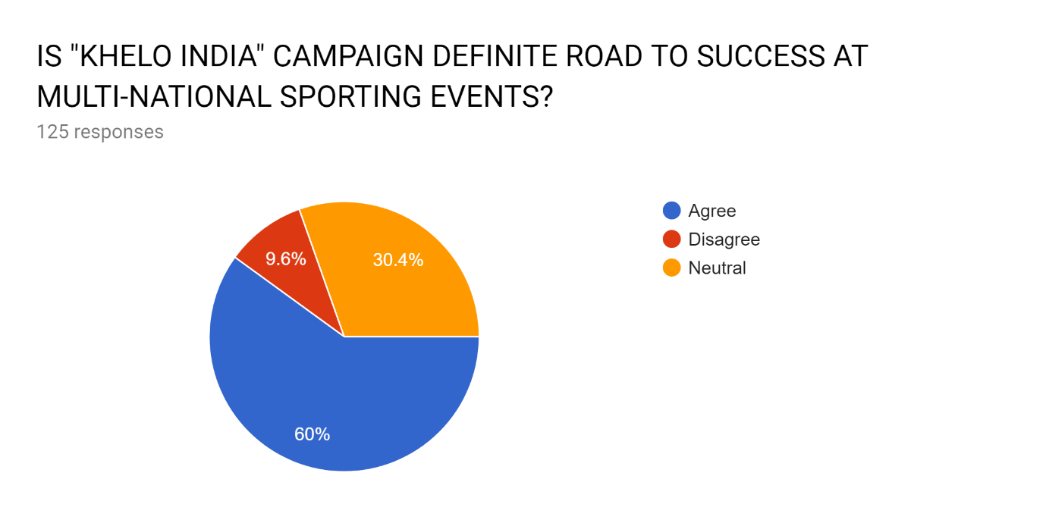
The response to this question is mixed one. Some people feel it supports capitalist. Some people feel it doesn’t. So the conclusion which can be extracted from here is that BJP is neither capitalist nor socialist. It follows Integral humanism. This concept was given by Pandit Deendayal Upadhay after analysis various economies or form to understand the notions. This philosophy believes in “antoyodaya” which means giving to the people who is last in line. It helps in wholesome development of economy. Capitalist is born in American economy whereas socialist is the work of Russia. So both have some defects. So it is combination of both. This is the best philosophy for our country and we are seeing the achievements of Bhartiya Janta Party which is the example of the success of this philosophy.
People have liked this “KHELO INDIA” campaign of government. 60% of people have agreed that it will increase the exposure for sports at multi-national sporting event. So from the responses of this particular question asked it could be concluded that the Indian tricolour will rise more often at international events and the Khelo India programme will create a sporting revolution in the country; the way Indians look at sports will change.
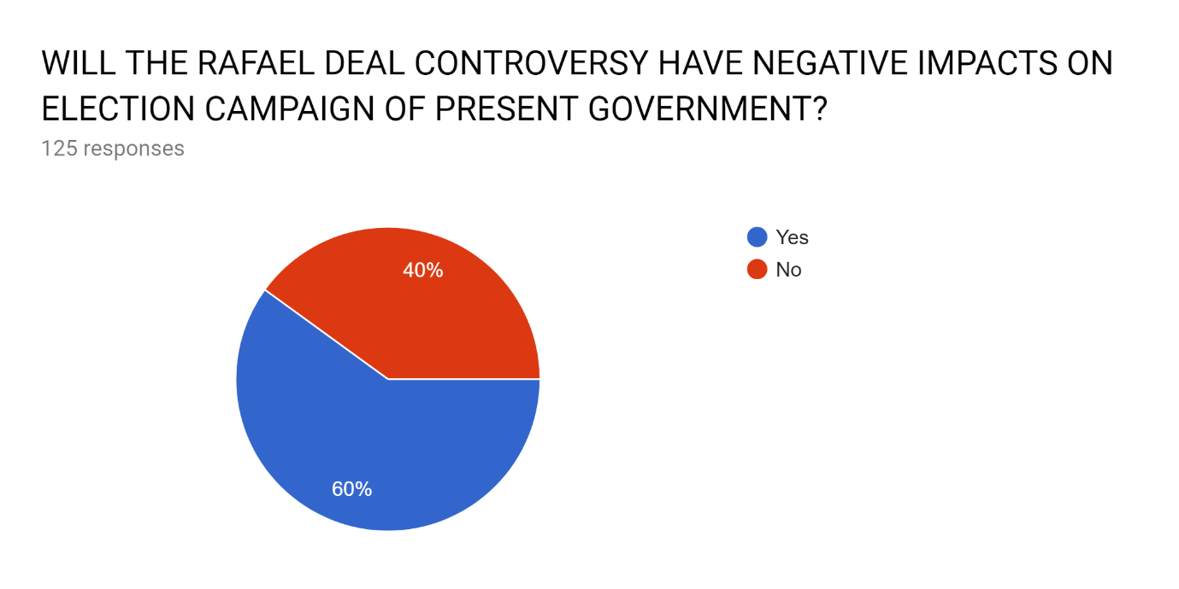
The Rafael Deal controversy is the very first corruption allegation on the present government. This has certainly given the opposition a subject around which their election campaign can be designed. The current government came into power on the basis of corruption as their basic agenda and now they find themselves in potential trouble.
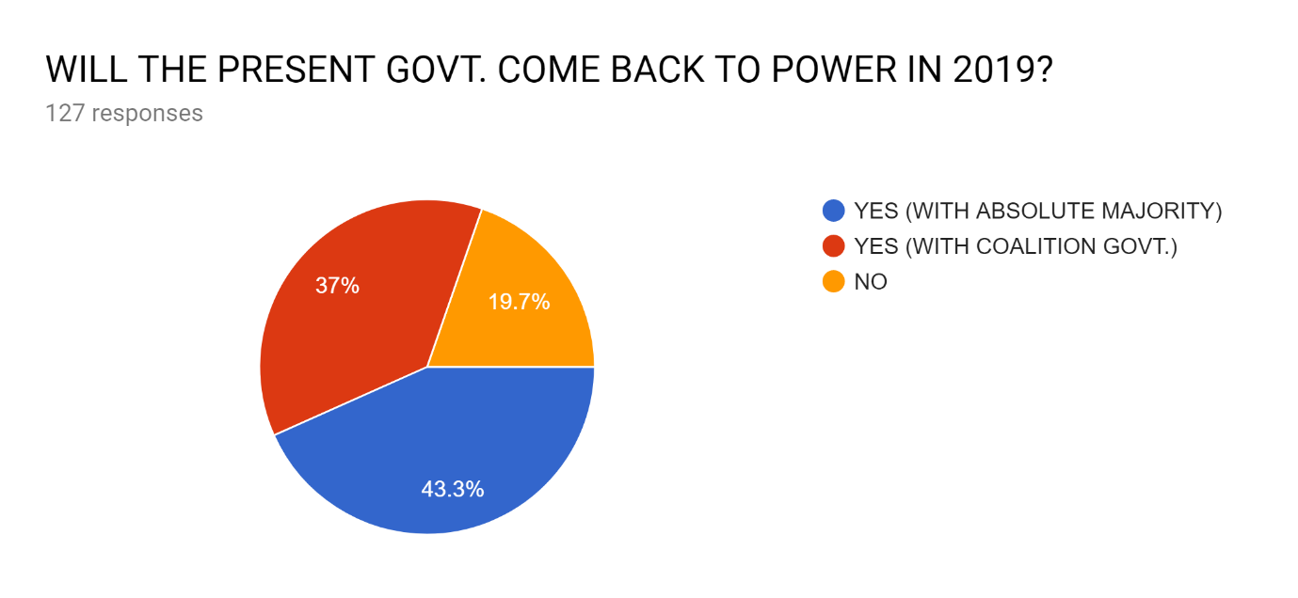

With this question it can be judged that people who voted for yes (with absolute majority )are fully satisfied with the present government and quite a large share of responders look a bit divided as to what their prediction is. One thing that can be concluded is the fact that at the moment the opposition is not the strongest so the people are void of options which can help the present govt. to get re-elected to power.

RESEARCH METHODOLOGY
Data collection
There are two types of data collected:
∙ Primary Data
∙ Secondary Data
Primary data is collected for a specific purpose and is new information. This is conducted using some means of questioning usually via a survey or interviews, or the information can be gathered through observation. It is typically more time consuming and expensive to collect than secondary data and is often the second stage in a research project, following secondary research.
Examples of primary data include:
- surveys
- interviews
- observations
- ethnographic research
Secondary data is the information collected which has already been gathered. This is a valuable way to start a research project if possible, as it identifies any relevant data before time and money are spent on new primary research, which may result in duplication.
Examples of secondary data include:
- published market research reports
- articles which can be downloaded from the Internet
- publications in libraries including online libraries
- company reports and data
- trend data

Sample Size
We received 133 responses in the survey conducted in which the respondents sincerely expressed their views on ‘THE FATE OF BJP IN ELECTIONS 2019. Controls were used to eliminate duplication of the responses.
Sampling unit
The respondents involved in this survey belong to THAPAR INSTITUTE OF ENGINEERING AND TECHNOLOGY located in Patiala district of Punjab. The respondents belong to the age of less than 18 to above 50 years.

Scale used
In this survey, Likert scale was used to receive the responses form respondents. Likert Scale is a psychometric scale where questions based on this scale are normally used in a survey. It is one of the most widely used question types in a survey. In a Likert Scale Survey respondent simply don't choose between "yes/no", there are specific choices based on "agreeing" or "disagreeing" on a certain question in the survey. Likert scale survey questions are essential in measuring a respondent's opinion or attitude towards a given subject. For example, typical multiple-choice options include Strongly Agree, Agree, No opinion, Disagree and Strongly Disagree which has been used in this survey.
Sampling technique
Simple statistical techniques were used to tabulate the results of this study. The primary data were analysed using a percent of response. To compute the percent of response, the number of responses to each choice was divided by the total number of respondents who answered the question. A nonprobability, convenience sampling technique was used to collect primary data. Data for this study were collected using a questionnaire developed by a group of students at TIET. Each member of the research team was responsible for distributing the questionnaire to members of the sample. The questionnaire was made using google forms and distributed through social media.

CONCLUSION
The survey is intended to get a rough idea as to where the public opinion is heading ahead of the General Elections 2019. After compiling and studying the results of the survey which was carried out on the Google Forms, a fair idea has been obtained as to what can be expected as the outcome of the biggest celebration of democracy.
Certain sectors of the government like the Foreign Ministry and Defence Ministry have, in particular, impressed the public. This can be attributed to the way our Prime Minister has carried himself at various Global Summits and other bilateral meetings held in India or abroad. The Defence Ministry has impressed one and all by the ‘Surgical Strikes’ and a successful S-400 Missile System deal with Russia.
Finance Ministry seems to have disappointed the public with policies and reforms, which looked good in principle but weren’t executed that well. For example GST implementation and Demonetization.
Certain recent initiatives like ‘Cashless India’ and ‘Digital India’ have impressed the public by their intent. These initiatives give a strong case for the present govt. to build around. Also some landmark decisions like
- Ordinance regarding death sentence to rapists
- Decriminalisation of Section 377 and Section 497
- Abolition of triple talaq
Have brought a progressive thought process into the Indian society by getting over the stereotypes of the society.
All in all the public gives an impression of being divided over who they really want at the helm of powers in New Delhi. Presently the opposition also doesn’t look convincing either in its arguments or in its leadership. The ‘Rafael Deal Controversy’ and a united opposition has certainly provided with some spice in the competition.

LIMITATIONS OF THE REPORT
Although the survey has reached its aim, but there were some unavoidable limitations, and those limitation are mentioned below
• Time constraints: As there was as shortage of time for the survey, we had only 3 weeks to complete our survey, so we looked for faster method rather than best methods.
• Sample size: Since we had less time we were unable to reach maximum people, so we had to settle with limited response which led to inconclusive results.
• Financial constraints: We were not provided any funds from the institution, so we were unable to spread our survey in an effective and large manner.
Difference in the understanding and interpretation : The trouble with not presenting questions to users face to face is the each may have different interpretations of our questions .Without someone to explain the questionnaire fully and ensure each individual has the same understanding results can be subjective.
Skipped questions: When using questionnaire, there is a chance that some questions will be ignored . if questions are not required , there is always that risk they won’t be answered,

REFERENCES

https://www.mea.gov.in/
https://www.mib.gov.in/
https://docs.google.com/forms/u/0/
https://www.youtube.com/?gl=IN

Manoj Sharma, Indian Government and Politics, Anmol Publications Private
Limited, New Delhi, 2004.
Ghoshal, H.D., (et.al)., Theory and Government and Politics, Unique Publishers,
New Delhi, 2000.
Prem Arora, Political Science Indian Government and Politics, Paper I (Section B),
Cosmos Bookhives, New Delhi, 2008.
http://shodhganga.inflibnet.ac.in/bitstream/10603/173689/9/09_chapter%203.pdf

